SerialManager public Method

* void SetSerialOpen() // serial port open
* void SetStartSerial() // change serial information and start serial thread
* void SetSerialClose() // serial port close & stop serial thread
* void SetSerialPort( string PortName ) // set serial port name ( default : COM8 )
* void SetBaudRate( int BaudRate ) // set serial baud rate ( default : 9600 )
* void SetReadTimeout( int ReadTimeout ) // set read timeout ( default : 500 )
* void SetWriteTimeout( int WriteTimeout ) // set write timeout ( default : 500 )
* void SetHandType( char type ) // set hand type ( default : “R” )
* void SendVibrationMessage( int type, int strength ) // send vibration message
* char GetHandtype() // return hand type ( “L” or “R” )
* Vector3 GetAngleValue() // return object’s angle value
* Vector3 GetPosValue() // return object’s position change value.
* int GetFingerValue() // return finger value ( 0 ~ 31 )

How to run SerialManager

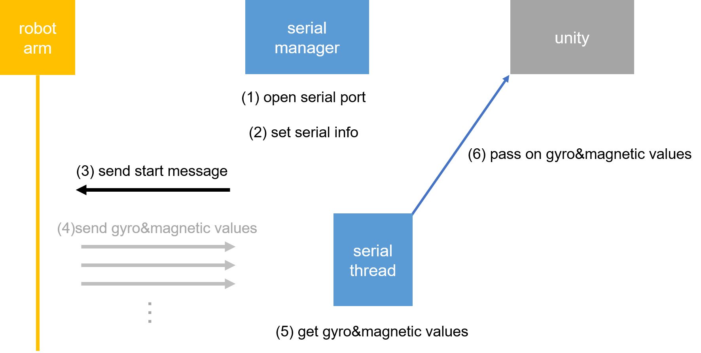

Serial Communicatino Rules

